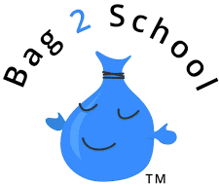

Dear Parent/Guardian,

Make a difference by raising money for Highfield School, while creating awareness of the benefits of recycling.

- Charity event: Clothes & shoe collection with Bag2School
- Funding for: Highfield School
- Who are Bag2School? The UK’s leading textile recycler and fundraiser, having paid out over £32 million to schools.
- Benefits: Raising funds and helping the environment by diverting unwanted textiles away from landfill.
- The facts: As a nation, we still send 350,000 tonnes of textiles to landfill every year.
- Get involved: Sort through your wardrobes and donate unwanted textiles in the bag provided.
- What can I donate?
Adults’ clothes | Children’s clothes
Hats | Belts
Handbags | Soft toys
Curtains | Towels
Bedding | Shoes (tied together)

- For more information: www.bag2school.com
- Feeling generous? If one bag isn’t enough, use additional bags from home.
- Who to ask: Grandparents, friends and neighbours can have a sort out as well!
- When & where: Leave them in the pram shelter outside Reception on
the morning of Friday 22nd March, not before please.

Many thanks,
The Friends of Highfield
‘Together we can achieve more!
www.highfieldprimary.co.uk friendsofhighfield@hotmail.com Facebook & Instagram: The Friends of Highfield
www.bag2school.com

