Curriculum assessment at the end of KS1 - Handout
Strategies we use to support your child.
Reading
- Underline key words in the question.
- Look for those words in the text and underline them.
- Discuss what sort of answer the question words demand
e.g. Where? = a place. Why? = an explanation.
- Locate the answer within the text.
- Write the sentence and check it answers the question.
- Look for clues in the text – inference.
- Develop vocabulary and talk about the author’s choice of words.

Maths
- Draw number lines
- Draw pictures
- Draw place value grids

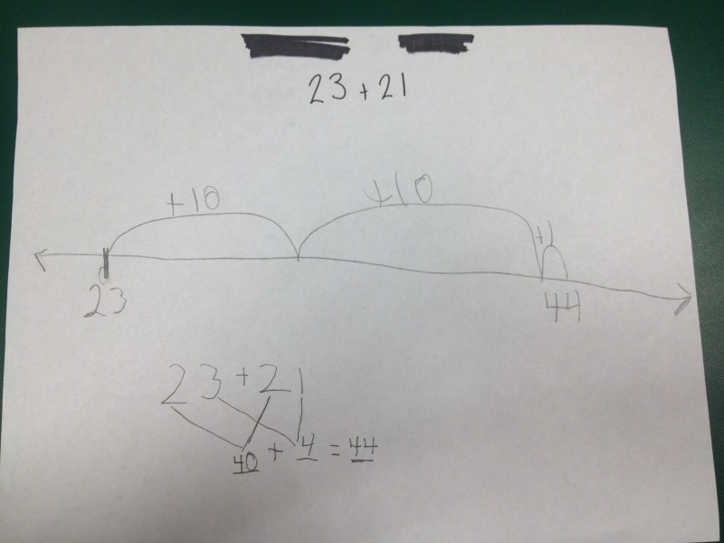

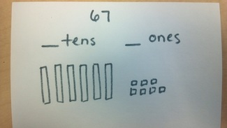
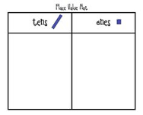

How can I support my child at home?
- Listen to your child read regularly and record comments in their diary.
- Ask the question types shown at the front of the Home School Books.
- Help them to learn to read and write the spellings every week.
- Encourage your child to use Spelling Bug to become familiar and confident with the new Spelling, Punctuation and Grammar content.
- Ensure that they are familiar with key vocabulary e.g. adjective, noun, verb, past/present tense.
- Work with your children on their maths target. Learn the times tables and number pairs to 20 and practise them regularly.
- Ask them to explain homework tasks to you and encourage them to complete the tasks independently. Try to get them used to reading through their writing and checking for correct punctuation/tense.
Interim Teaching Assessment Standards -ITAFS
Reading Standards
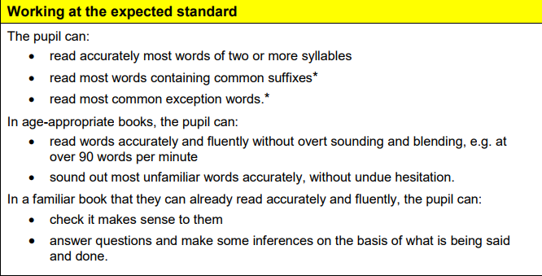

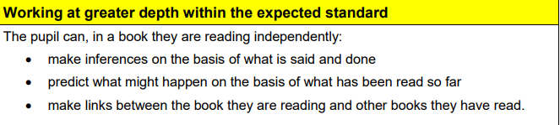

Writing standards
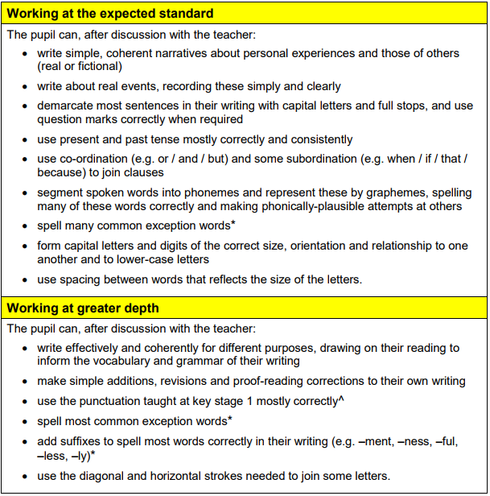

-

Maths Standards

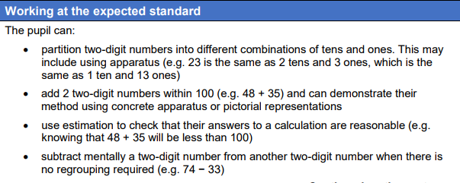
Maths Standards

